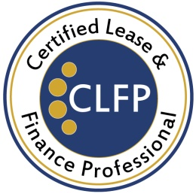

August 12, 2019

CLFP Foundation Adds 10 New CLFPs

The Certified Lease & Finance Professional (CLFP) Foundation is pleased to announce that ten individuals who recently sat through the 8-hour online CLFP exam, have passed. They are:

* Nerio Gonzalez Sanchez, CLFP – Vice President of Credit and Operations, Global Financial & Leasing Services LLC
* Cindy Grover, CLFP – Funding Coordinator II, Financial Pacific Leasing, Inc.
* Dan Kats, CLFP Associate – Audit Manager, ECS Financial Services, Inc.
* Yuman Li, CLFP – Staff Accountant, ECS Financial Services, Inc.
* Julie Miller, CLFP Associate – Manager, Customer Success, ConnectedFi
* Wyman Rothanburg, CLFP – National Account Manager, Northland Capital Financial Services, LLC
* Julian Sirull, CLFP – Broker Relationship Manager - Western Region, Global Financial & Leasing Services LLC
* Mark Stephany, CLFP – Equipment Finance Specialist, RBC-WM channel, First American Equipment Finance
* Stacey Thompson, CLFP – Loan/Lease Servicing Specialist, First Foundation Bank
* William Thomsen, CLFP – Operations Manager, Better Business Funding, LLC

“I chose to pursue the CLFP designation primarily to get in tune with the many standards and regulations of our leasing industry, and to gain a thorough understanding of the entire business cycle. Future recertifications will allow me to keep up to date as regulations change. Being a CLFP gives me the privilege of belonging to an exclusive group of industry professionals and offers me the opportunity to help others who choose to pursue the CLFP designation,” stated Mr. Sanchez who attended the Academy for Lease & Finance Professionals hosted by Wintrust Specialty Finance.

The CLFP designation identifies an individual as a knowledgeable professional to employers, clients, customers, and peers in the equipment finance industry. There are currently 762 active Certified Lease & Finance Professionals and Associates in the United States, Canada and Australia. For more information, visit http://www.CLFPFoundation.org.