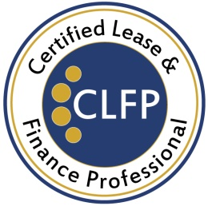

March 6, 2023

CLFP Foundation Adds 12 New CLFPs

The Certified Lease & Finance Professional (CLFP) Foundation is pleased to announce that 12 individuals who recently sat through the 8-hour online proctored CLFP exam, have passed. They are:

- Noah Barnard, CLFP – Assistant Vice President, Project Manager, First American Equipment Finance
- Joseph Dahm, CLFP – Vice President, Equipment Finance, Cadence Bank
- Thomas Harter, CLFP – Vice President, Project Manager, First American Equipment Finance
- Alicia Lester, CLFP Associate – Finance Manager, Ascentium Capital LLC
- Sarah Moreau, CLFP Associate – Assistant Vice President, Marketing, First American Equipment Finance
- Mackenzie Mynter, CLFP – Assistant Vice President, Project Manager, First American Equipment Finance
- Vi Nguyen, CLFP – Supervisor, ECS Financial Services, Inc.
- Michael Schober, CLFP Associate – Vice President - Sales, Ascentium Capital LLC
- Paul Smith, CLFP – Executive Business Development Manager, Smith & Nephew Inc.
- Cristina Triassi, CLFP – Assistant Vice President, Project Manager, First American Equipment Finance
- Griffin Walpert, CLFP Associate – Assistant Vice President, Project Manager, First American Equipment Finance
- Brandon Wilson, CLFP – Asset Manager, The Huntington National Bank

Mr. Schober attended the Ascentium ALFP in January and shared, “I’m fortunate to work for a company that places a strong emphasis on Education and Development; earning the CLFP designation helps demonstrate my commitment to Ascentium, our customers, and the equipment finance industry.”
Huntington National Bank hosted two Academies last year, including the highest attended class ever at 39 students. Brandon Wilson, who attended the fall ALFP said, “I was looking for a way to advance my career in the Equipment Finance industry and set myself apart. I also wanted to learn more about equipment finance and the CLFP course provided an amazing overview of the entire process.”
The CLFP designation identifies an individual as a knowledgeable professional to employers, clients, customers, and peers in the commercial equipment finance industry. There are Certified Lease & Finance Professionals and Associates located throughout the United States (including Puerto Rico), Canada, India, Africa, and Australia. For more information, visit http://www.CLFPFoundation.org.

